Claim Evidence Reasoning (CER)
- What is a CLAIM? A statement of something as a _________; an assertion of __________.

- What makes a good CLAIM?
  - Identifies what you ___________ from ___________________
  - __________________ the __________________ for the reader
  - A clear statement that answers the _______________ __________________
  - Uses _______________ ___________________
  - Does not include ___________________

Make a claim based on this question - Which professional sport is the most exciting to watch?
Claim: ___________________________________________________________________________________

- Claims are made after analyzing _____________________

- Evidence = ____________________, ________________________, data (table, graph), etc.

- What is EVIDENCE?
  - Scientific data that ___________________ the _______________
  - _________________ (directly related) to claim
  - Cites _______________ _________ OR
  - Describes _____________in data OR
  - ________________ & _______________ data

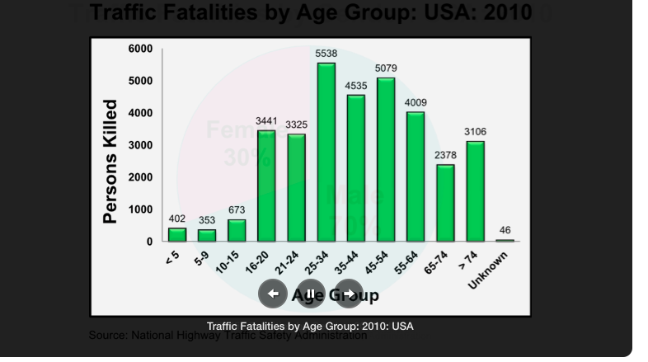
Example: How does age affect traffic fatalities?

Age Groups

Look at the graph and pull out two pieces of evidence that you will use to make a claim

EVIDENCE = _______________________________________________________

= ________________________________________________________

CLAIM = ___________________________________________________________________

- What makes good REASONING?
  - Your _____________________ for the claim.
  - Connects the ____________________ to the claim.
  - Uses _______________________ ______________________ .
  - Incorporates ___________________________ _______________________.

- Alien video:
